Banco de Espana Circular 2-2016 Compliance for Log360
Tagline: Meet Banco de España's requirements with centralized monitoring from Log360.

Overview
The Banco de España Circular 2/2016 (as amended by 3/2022) Compliance extension for Log360 helps Spanish credit institutions meet the IT governance, access management, and operational security requirements set out in Banco de España's supervisory circular.
Log360 collects and correlates logs from banking applications, core systems, cloud platforms, and network infrastructure, providing security and compliance teams with continuous visibility into IT security events. Teams can detect anomalies, investigate incidents, and generate the audit evidence required for Banco de España inspections and EBA supervisory reporting.

Key Features
- Generate predefined audit reports aligned to Banco de España Circular 2/2016 requirements covering access management, IT operations security, and incident monitoring.
- Track privileged user activities, core banking system changes, and access events across Spanish banking IT environments in real time.
- Centralize log data from across your infrastructure to maintain real-time visibility into user activity and access patterns, supporting proactive threat identification and compliance posture.
- Export compliance documentation in PDF and CSV formats for Banco de España supervisory examinations and internal IT risk governance.
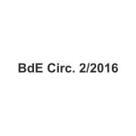
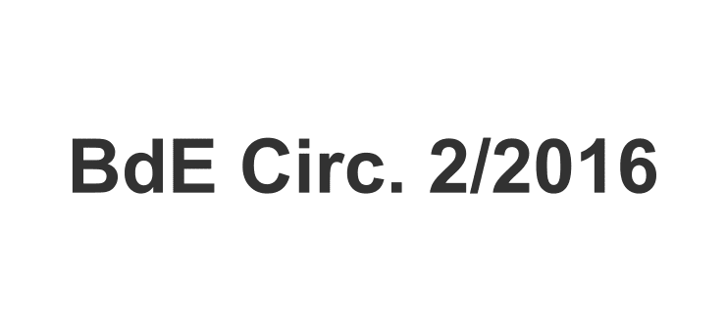

Screenshots
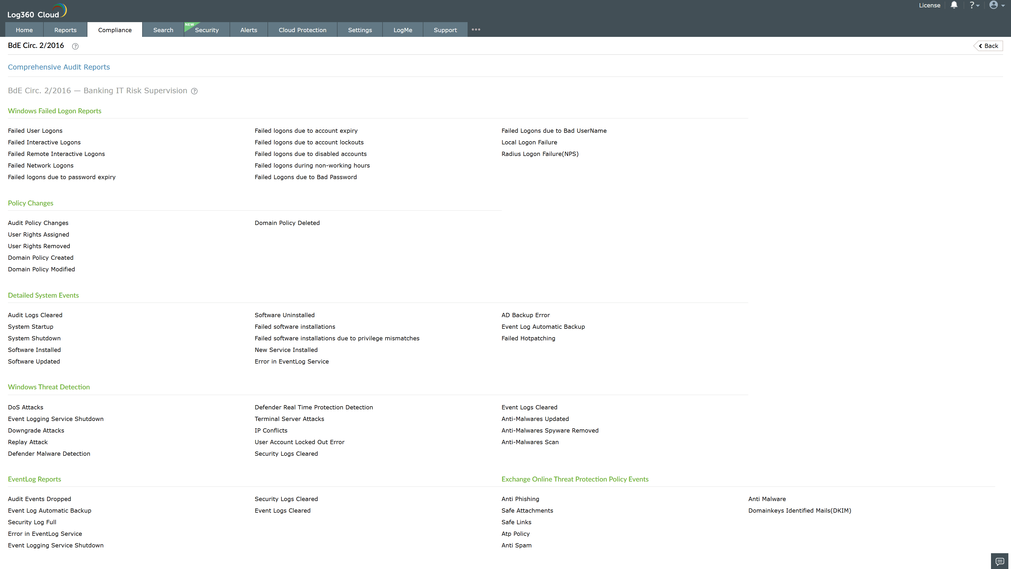
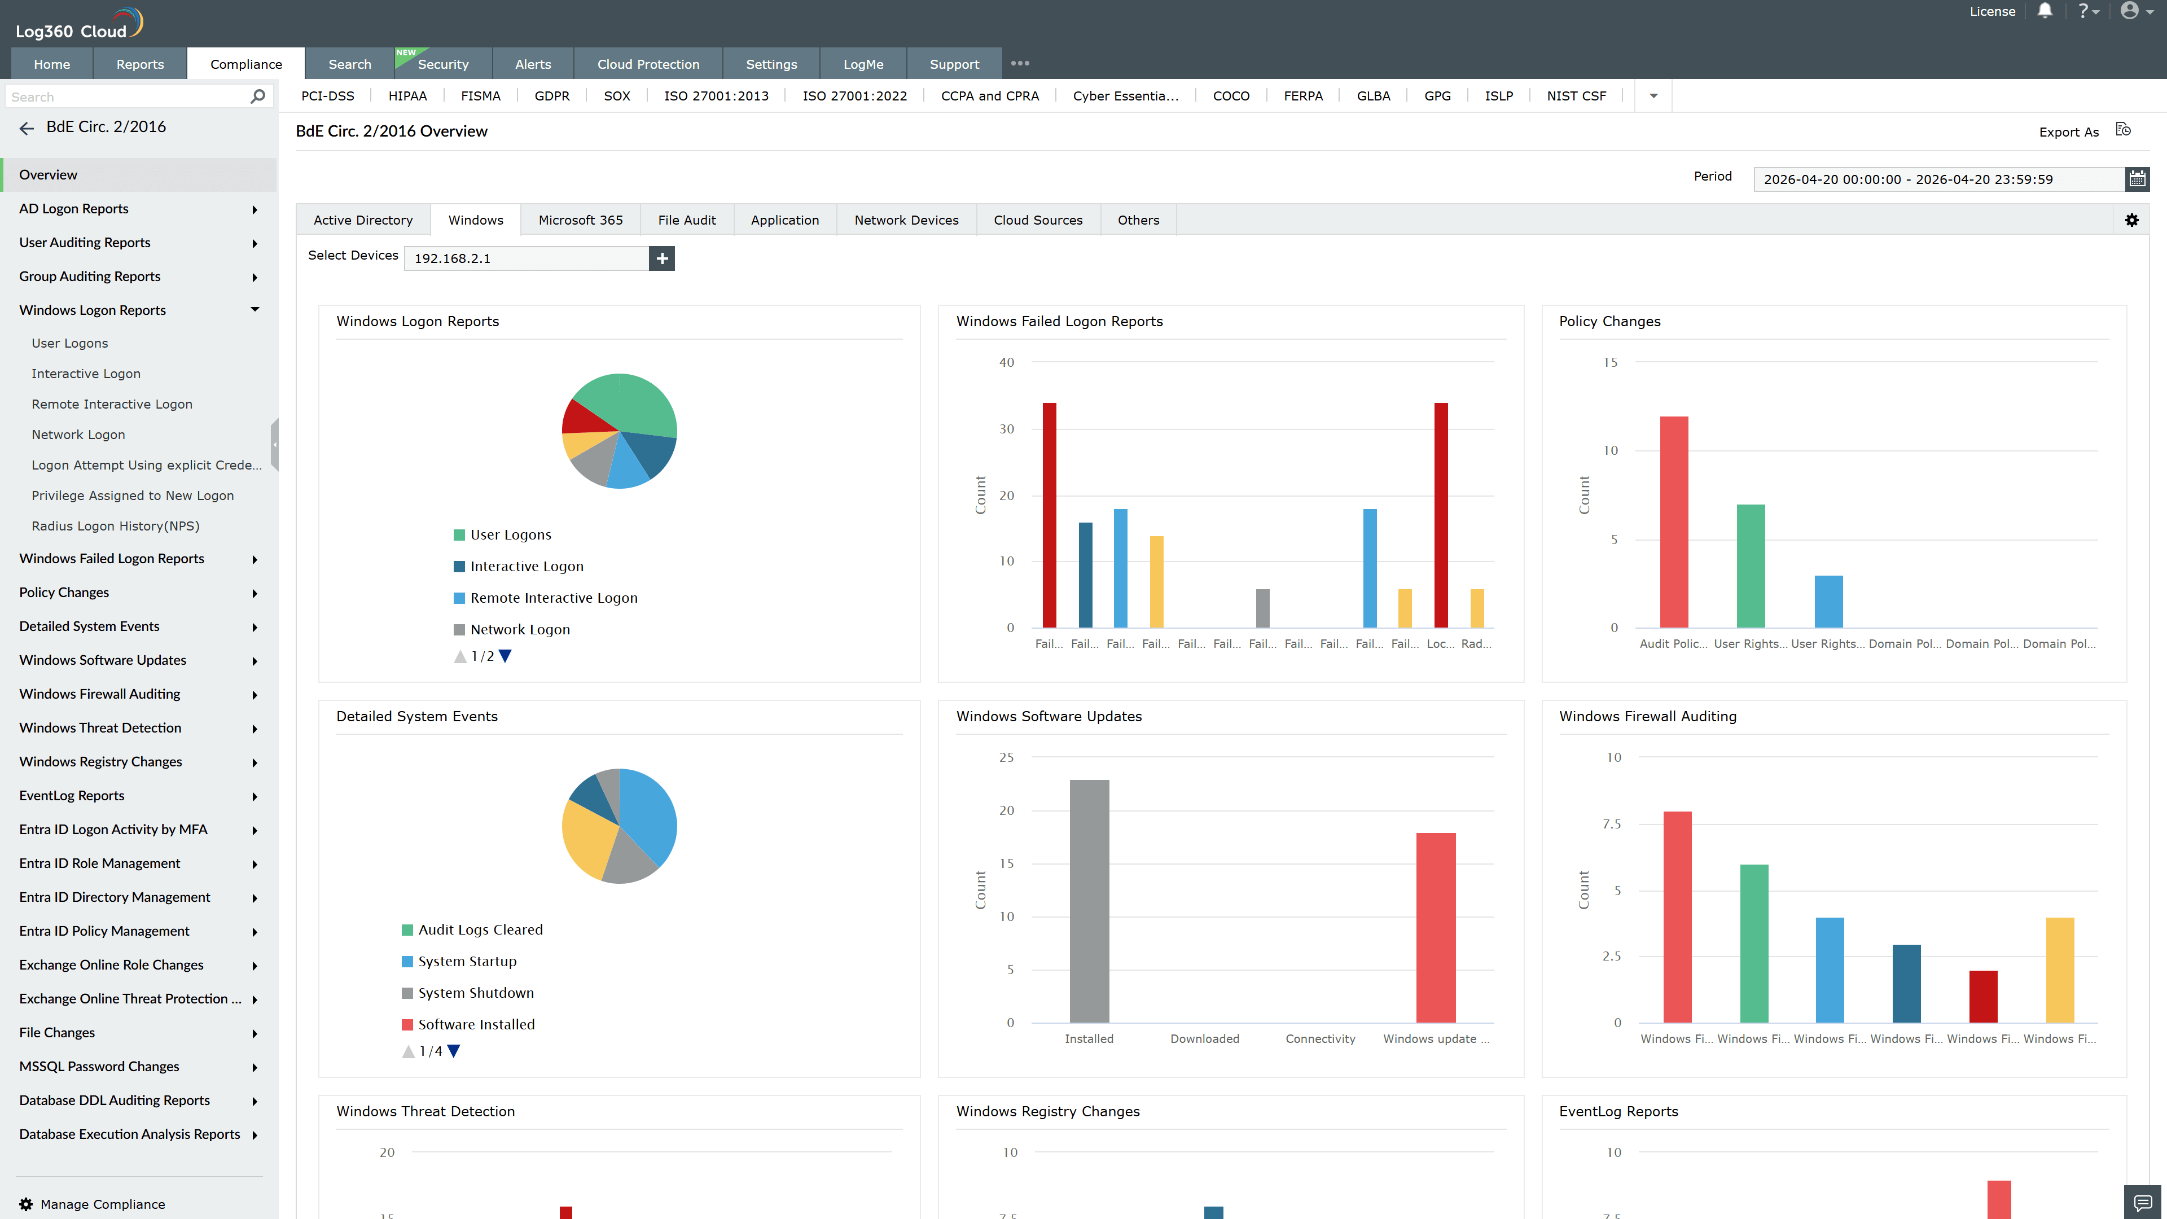
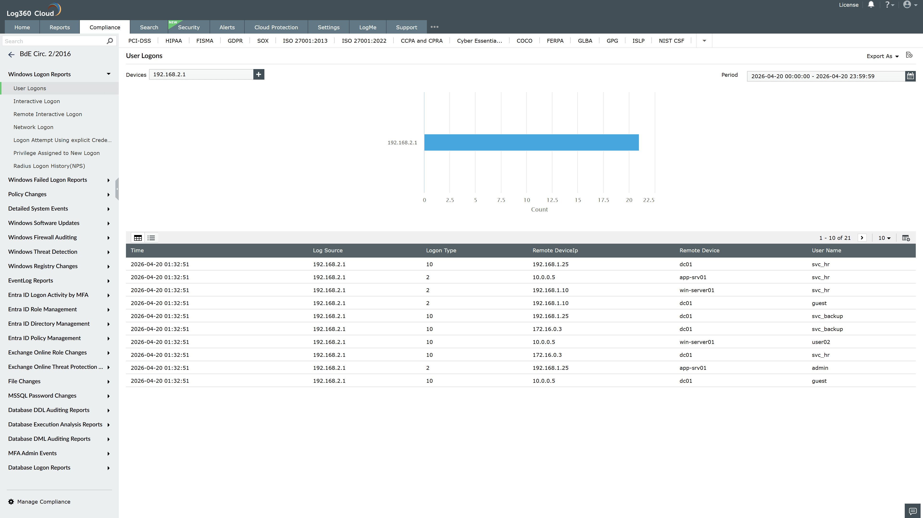
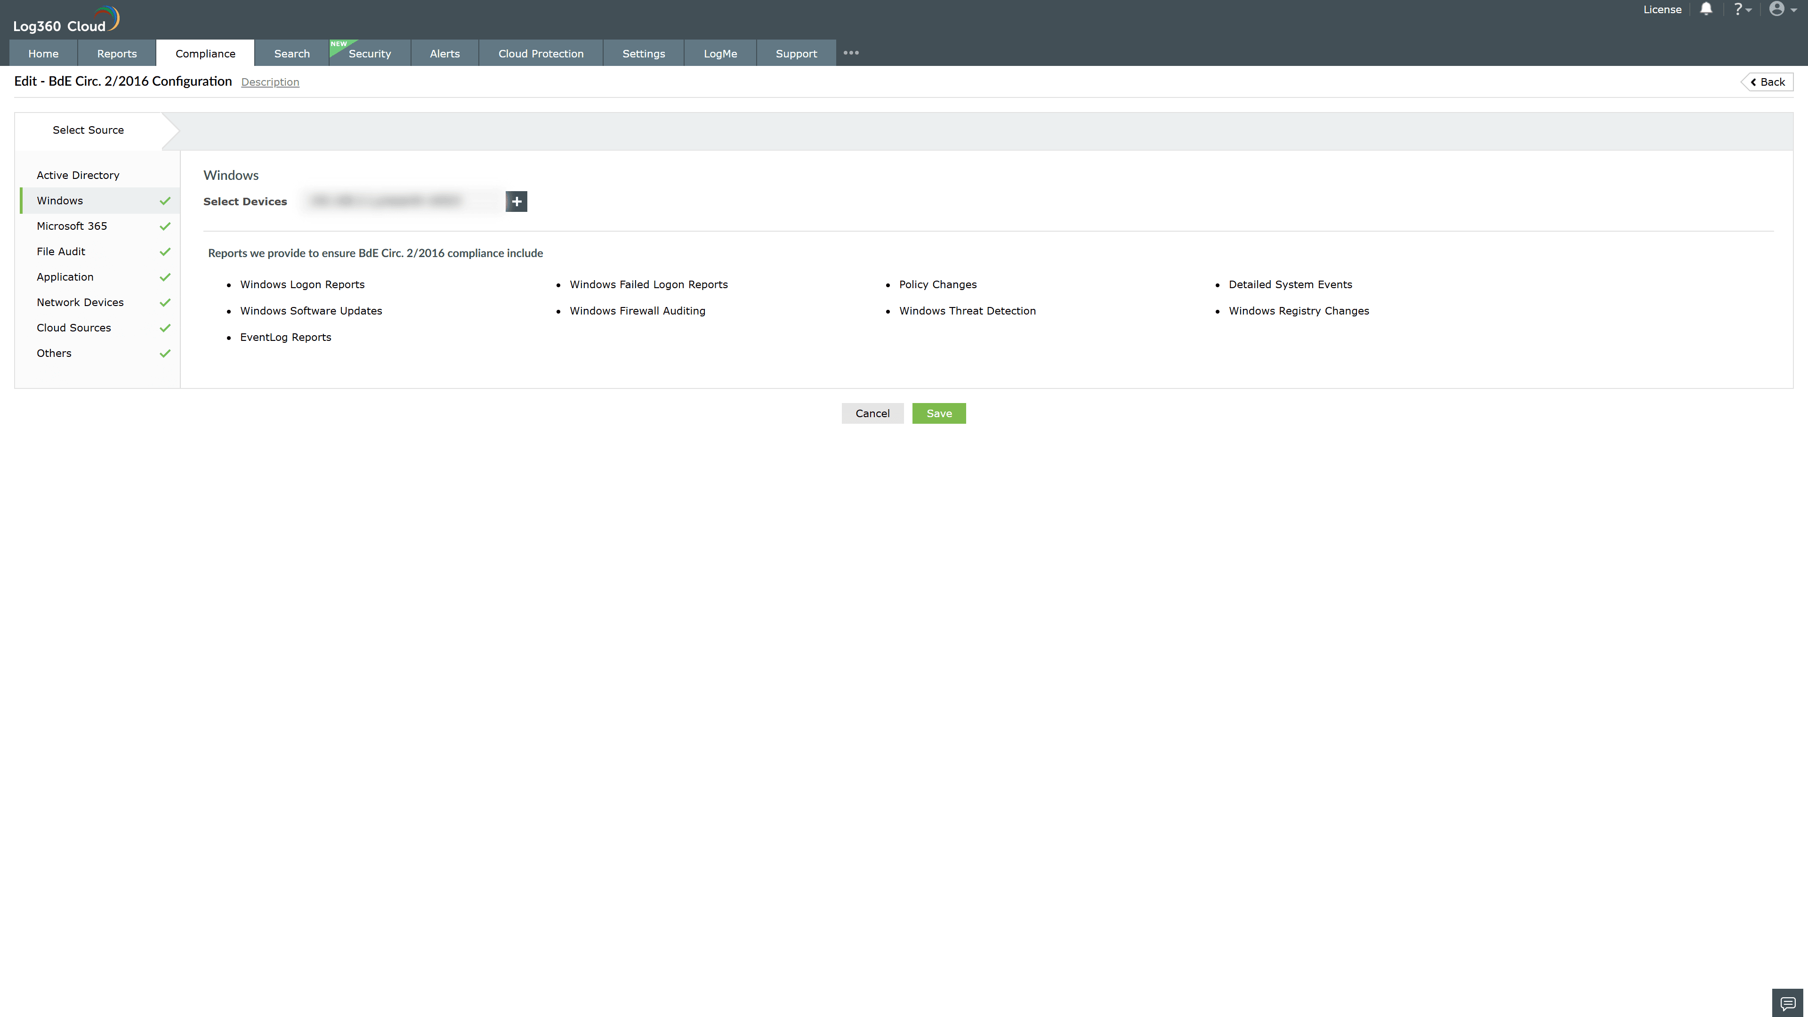

Valid Submission : Yes
Supported Editions : Free, Basic, Standard, Professional, MSSP
Help Document : https://www.manageengine.com/log-management/help/integrations/compliance-extensions.html
Help Video : Not provided
Tags : Log360, Compliance, Privacy monitoring, Data privacy, Regulatory compliance
Supported DCs : US, IN, JP, CA, AU, UK and EU
Privacy Policy:
Terms of Service:
Release Notes:
Predefined reports for the Banco de España Circular 2/2016 Compliance

